**Task 2.9**

**PROJECT OVERVIEW**

**Link:** <https://public.tableau.com/app/profile/aarthi.subramanian/viz/Task2_9_17156839400270/Task2_9?publish=yes>

**Motivation:** The United States has an influenza season where more people than usual suffer from the flu. Some people, particularly those in vulnerable populations, develop serious complications and end up in the hospital. Hospitals and clinics need additional staff to adequately treat these extra patients. The medical staffing agency provides this temporary staff.

**Objective:** Determine more vulnerable population states and when to send staff.

**Scope:** The agency covers all hospitals in each of the 50 states of the United States, and the project will plan for the upcoming influenza season.

**Influenza:** a contagious viral infection, often causing fever and aches.

**Vulnerable populations:** patients likely to develop flu complications requiring additional care, as identified by the Centers for Disease Control and Prevention (CDC).Population 65+ here considered as vulnerable population and analysis done based on this.

Link for source: https://wonder.cdc.gov/ucd-icd10.html

Here in pie chart, Population over 65 is more than population less than 65 years.

**I have added pie chart to show population over 65 is more.**

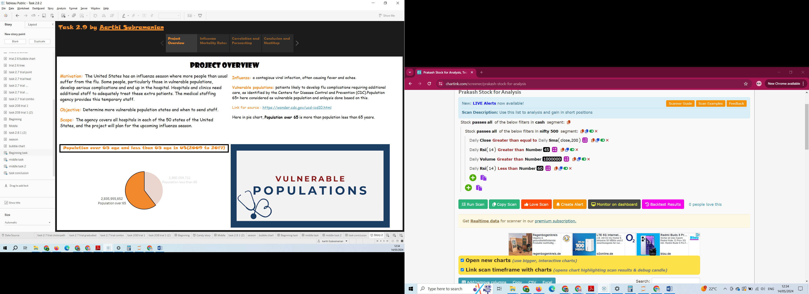

**INFLUENZA MORTALITY RATES**

Here I have added spatial analysis of highest and lowest population and death of 65 + age people also added annotations.

Also added top 10 states of highest mortality rate and added filters to select on state. So based on this spatial chart will update.

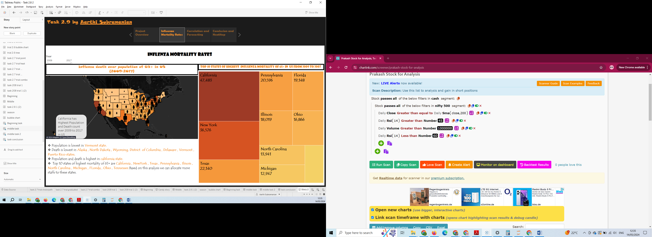

**CORRELATION AND FUTURE PREDICTION**

Here I have showed population and death have strong correlation.

And forecasted future death rate for 2018 and added highlights of states.

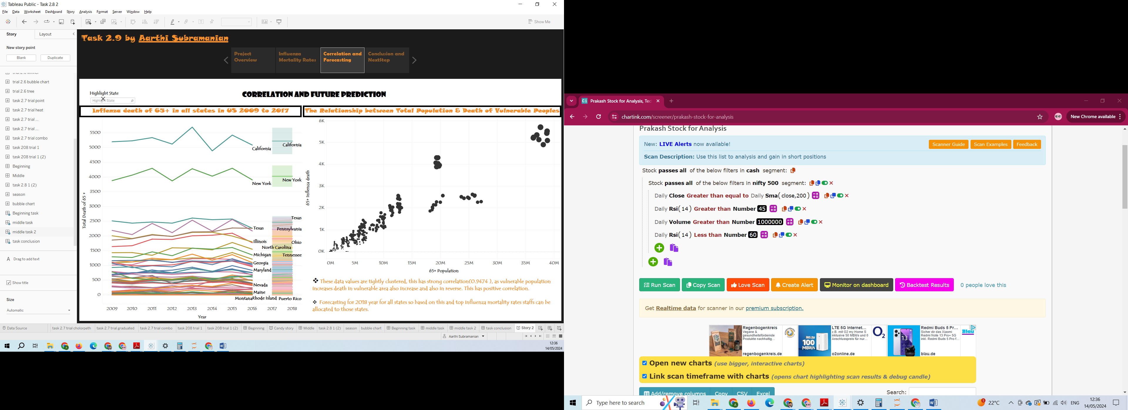

**CONCLUSION AND NEXT STEP**

Here added bubble chart of top 10 states with total number of deaths of 65+.

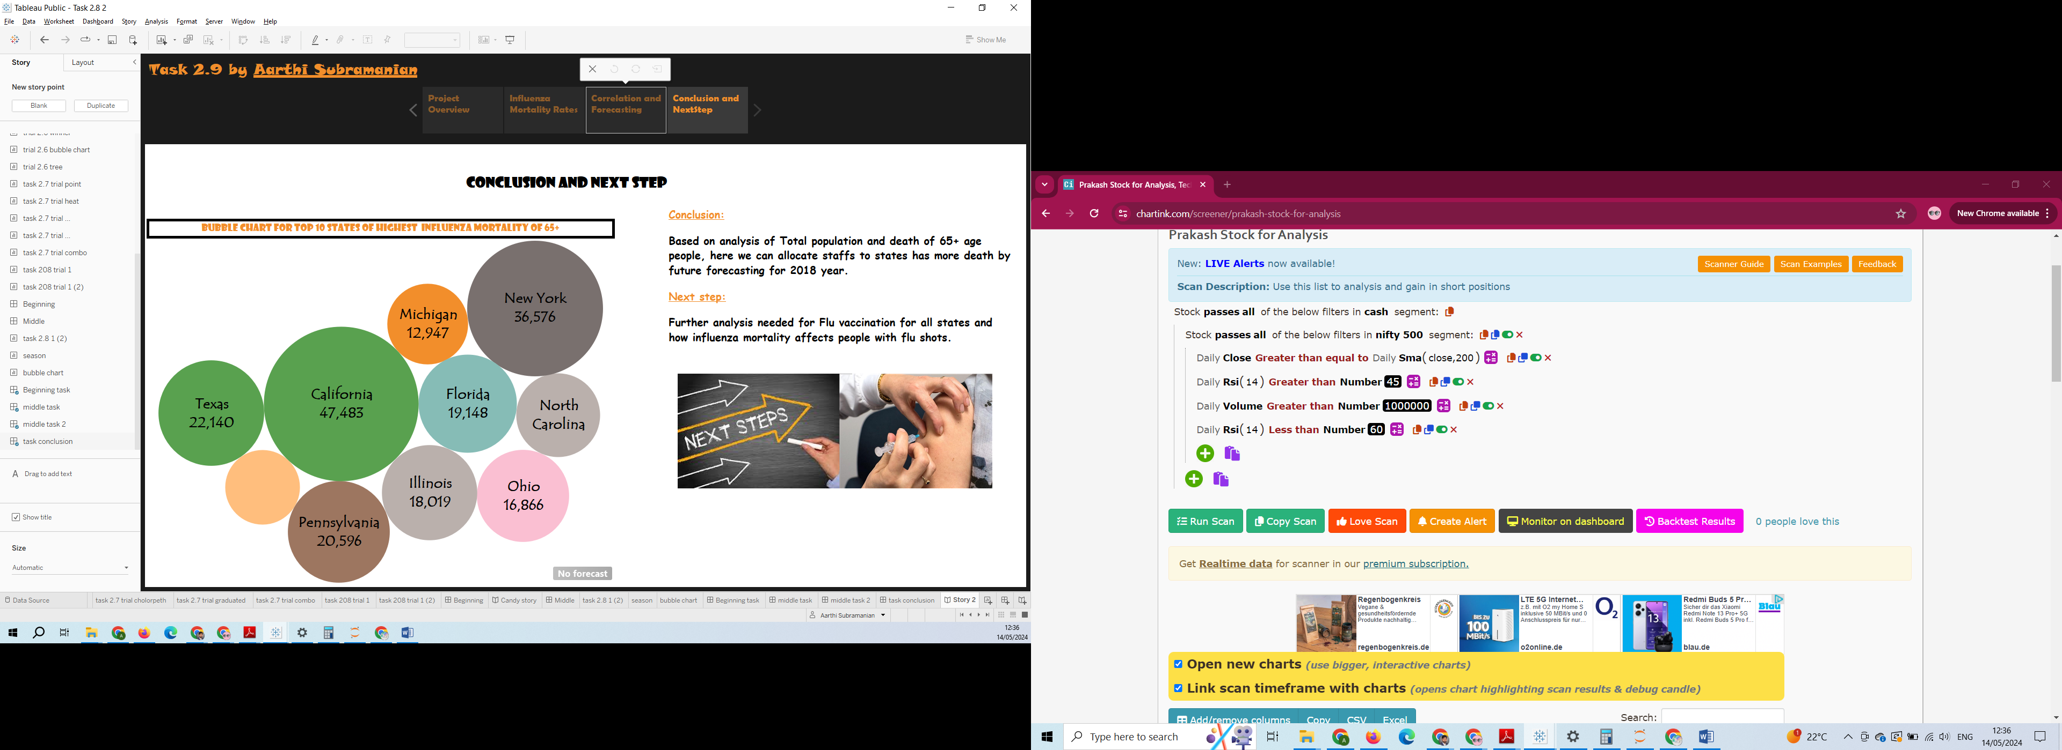

**Conclusion:**

Based on analysis of Total population and death of 65+ age people, here we can allocate staffs to states has more death by future forecasting for 2018 year.

**Next step:**

Further analysis needed for Flu vaccination for all states and how influenza mortality affects people with flu shots.